Outputs:
7 Performing one-way ANOVA using aov() (R).
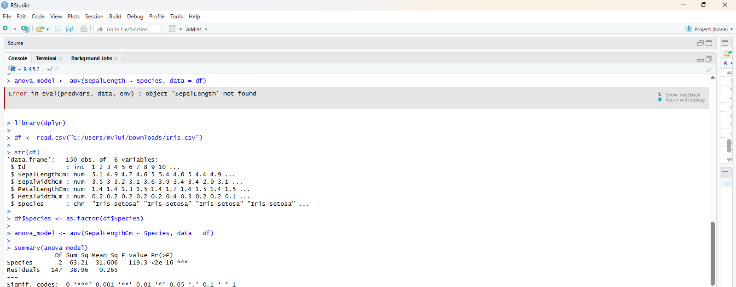
8 Performing two-way ANOVA using aov() (R).

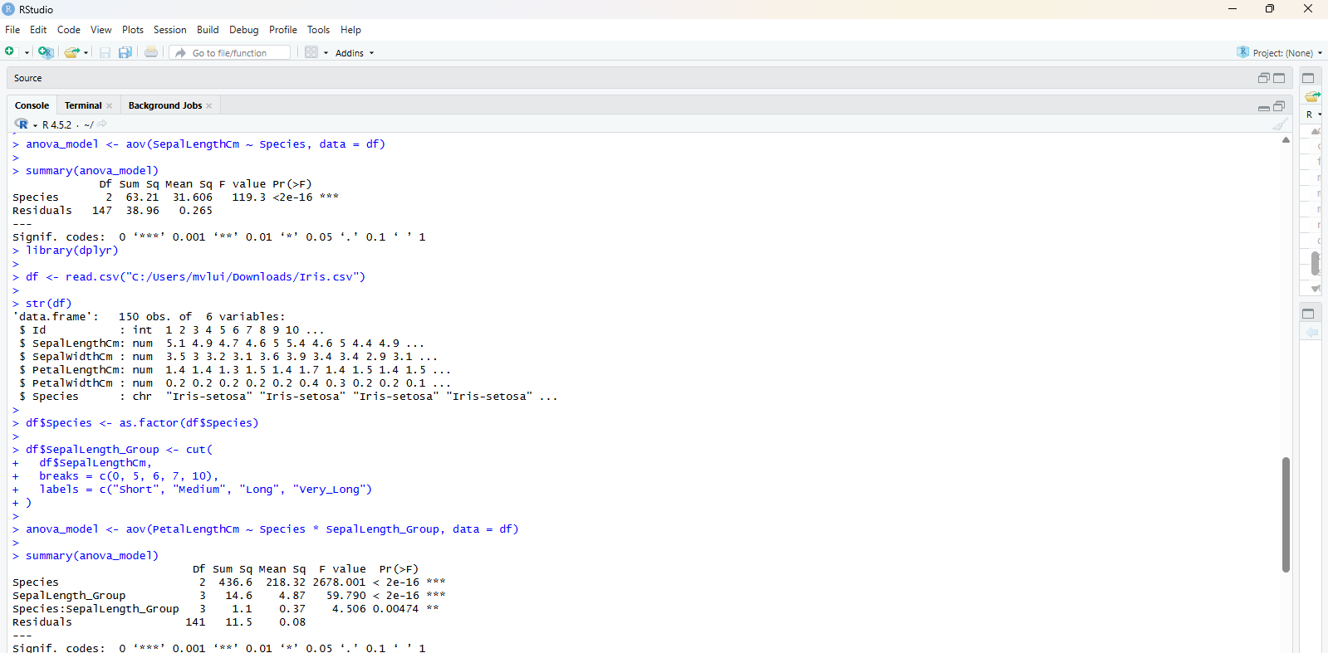

9 Conducting Chi-square tests using chisq.test() (R)
